C-GFLY Instruction Manual
by Cala Custom Woodworks
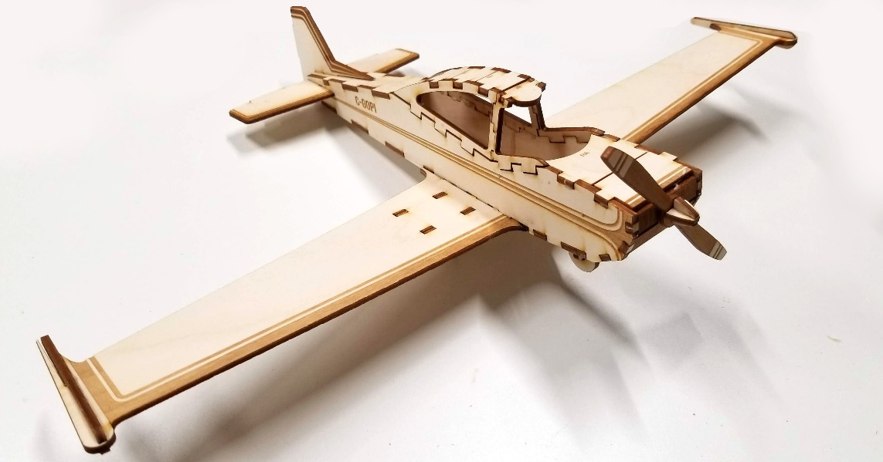

Getting Started: Separate all parts from the wood frame. There are quite a few intricate parts, so you may want to keep the smaller pieces together, you won’t need them until the final steps. Select parts are identified by numbers and letters. Tabs are labeled to match corresponding parts to help with alignment.
You’ll need some glue (wood glue or super glue), some tape and some patience when putting this model together.
Step 1a: Starting with the fuselage, apply small dabs of glue to the B1 and B2 tabs of the fuselage profile pieces. Tabs are labeled B1 and B2 on both pieces.

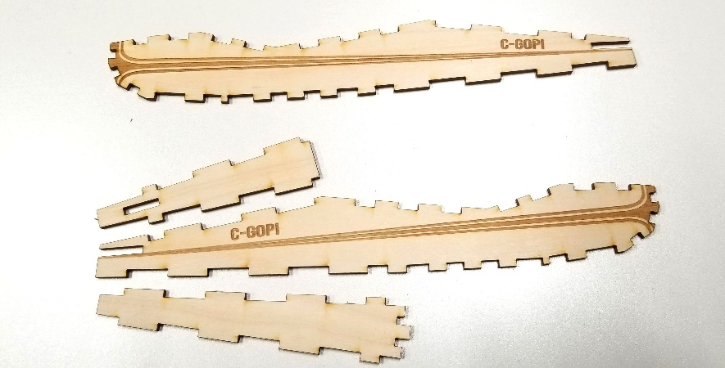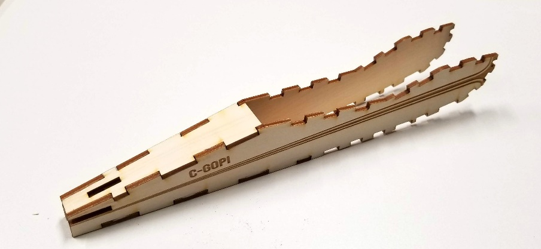
Step 1b: Attach A1. Apply some glue to the tabs of A1, and insert the tabs into the corresponding slots in the fuselage.
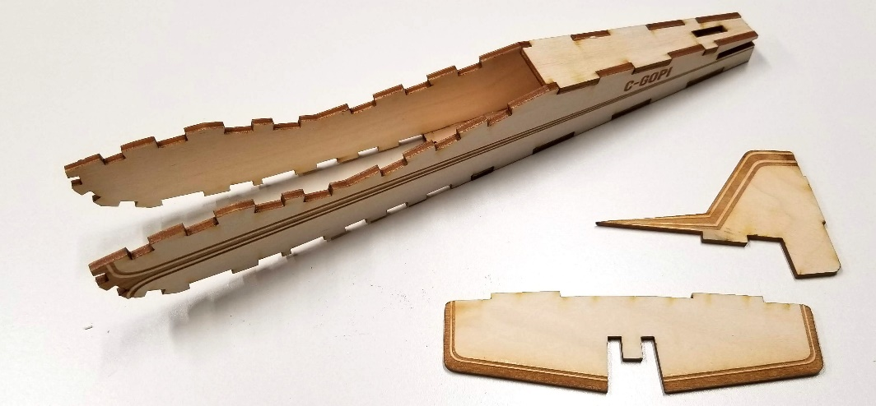
Step 2: Apply some glue to the inside of the notch in the horizontal stabilizer, and insert into the slot at the rear of the fuselage. Make sure to push it all the way in to that the back of the wing is flush with the back of the model. Glue on the vertical stabilizer but slotting the tab into the slot of A1. You may want to apply some tape to hold everything in place while the glue sets.
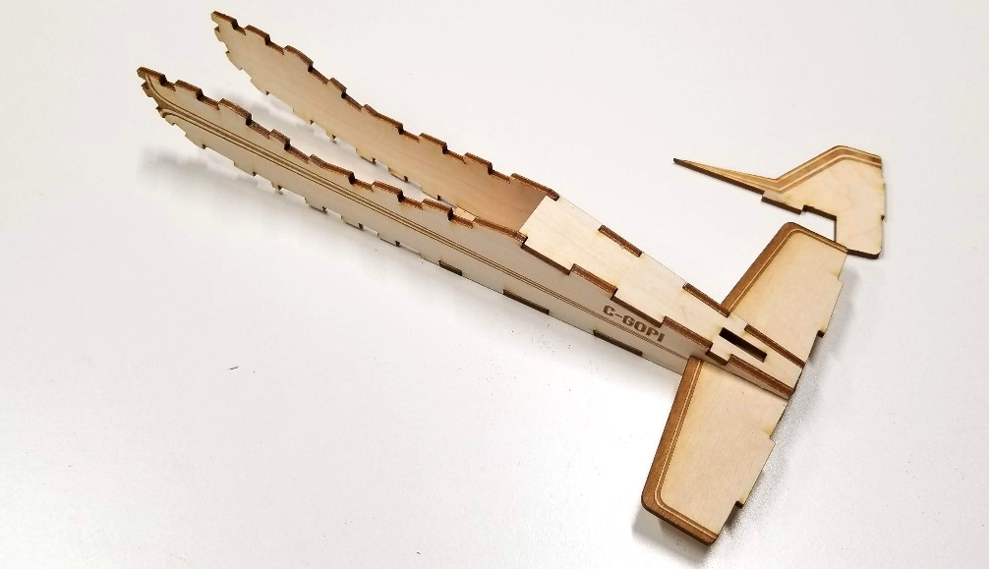
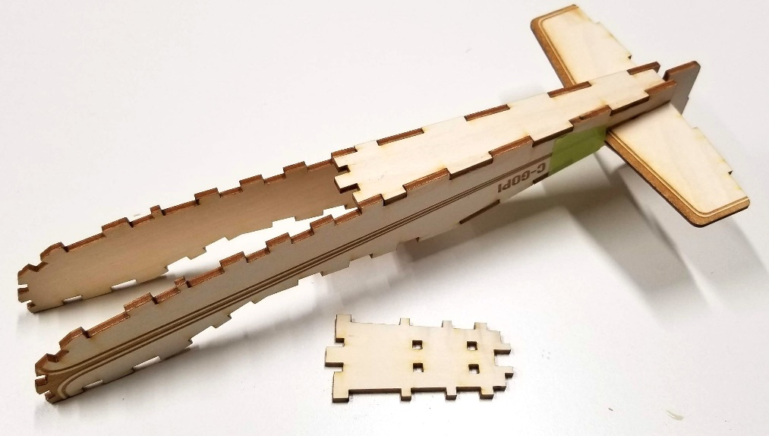

Step 3A: Apply glue and insert the tabs of B2 into the B2 slots on the bottom of the fuselage.
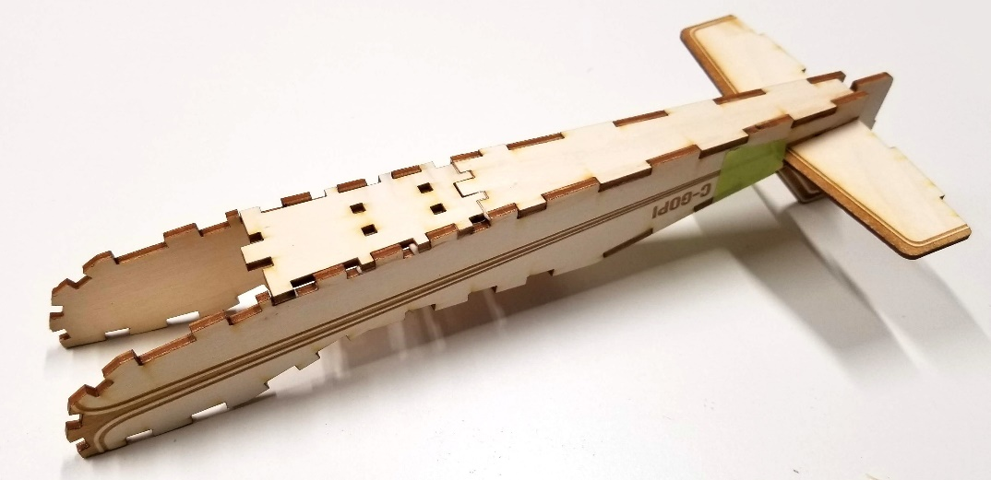
Step 3b: glue and place LG2 and LG1 into the appropriate slots on B2. Tape in place while the glue sets.
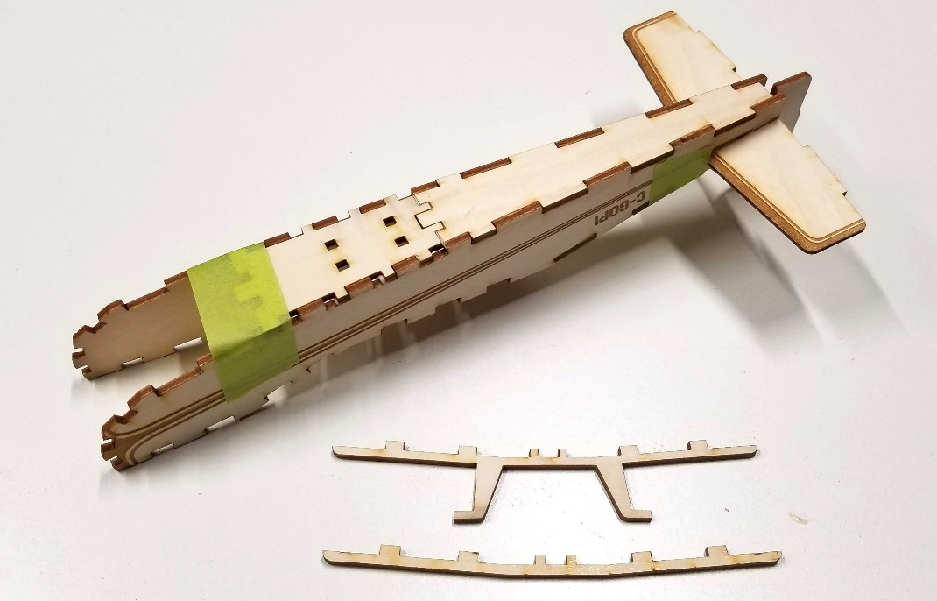
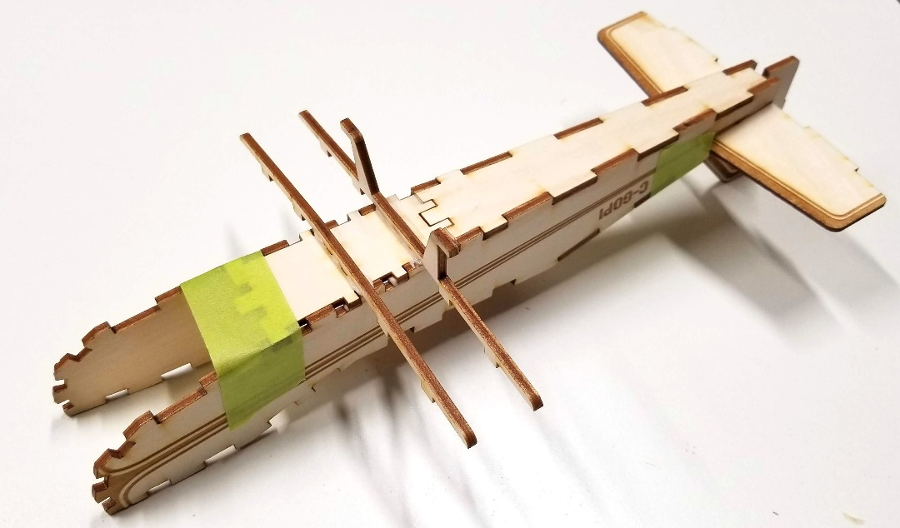

Step 4A: Prepare the pieces below for the front landing gear assembly. Stack the nose weights on top of B3, so that the square holes are aligned. Dab some glue in the slots and insert the ‘Y’ shape landing gear arm so that the 2 prongs reach all the way through,
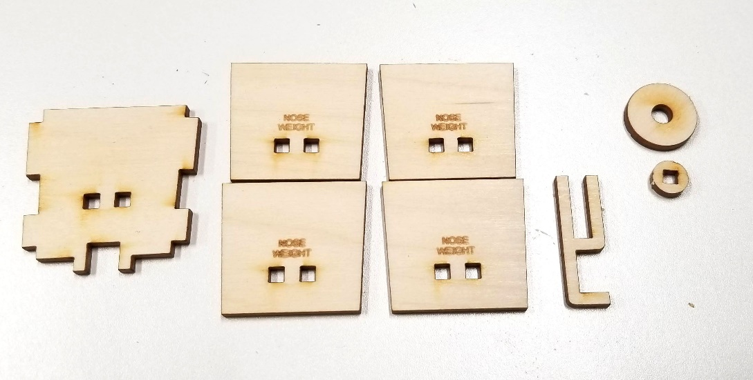
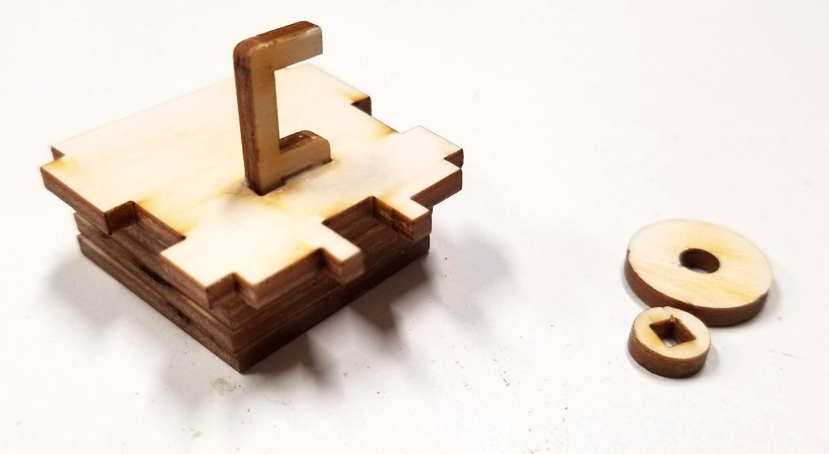
Step 4B: Place the wheel onto the axle (do not apply glue). Dab a small amount of glue to the square slot on the smaller circle. Connect with the axle, giving the wheel enough space to rotate freely.
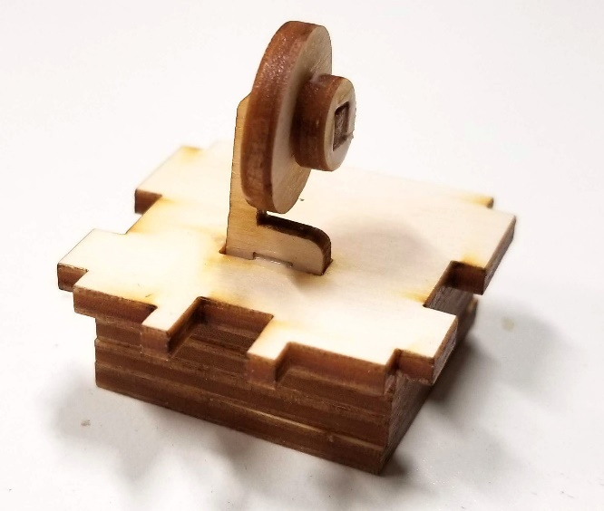

Step 4C. Glue and place the sub assembly into the B3 slots on the bottom of the fuselage.
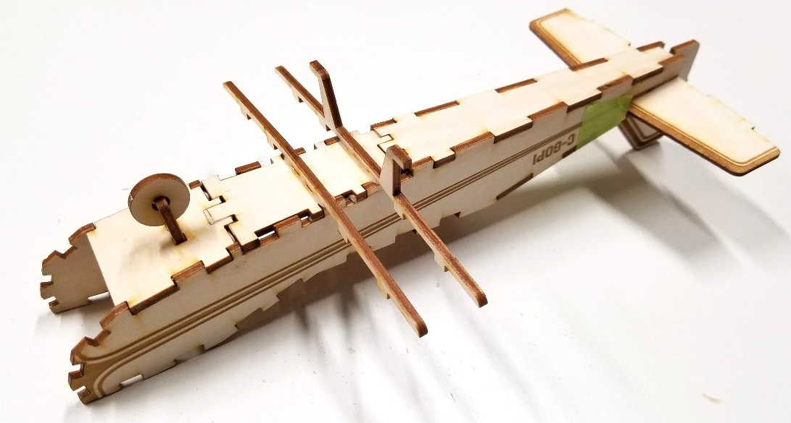
Step 5A. Select parts ND, NC and PM (unlabeled). Glue into the appropriate spots, with the etched side facing outward.
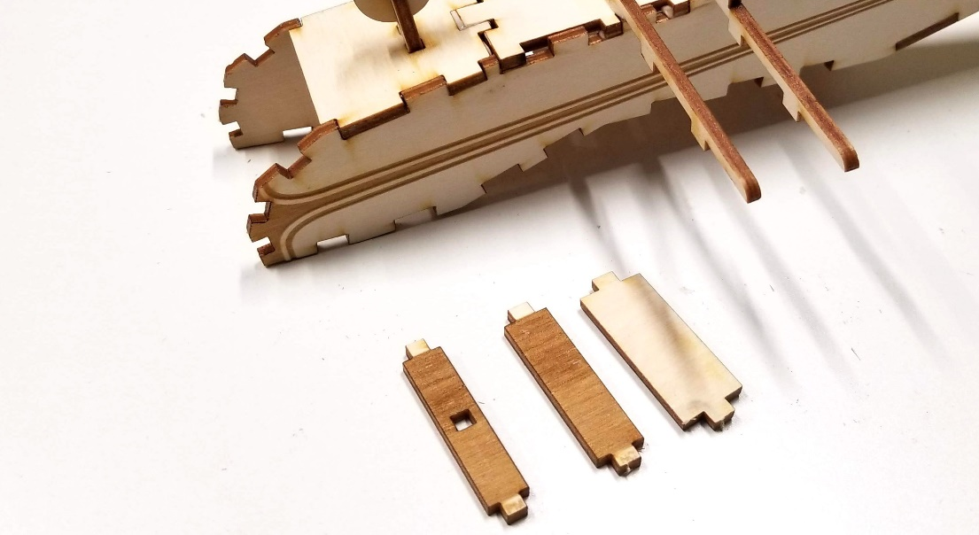
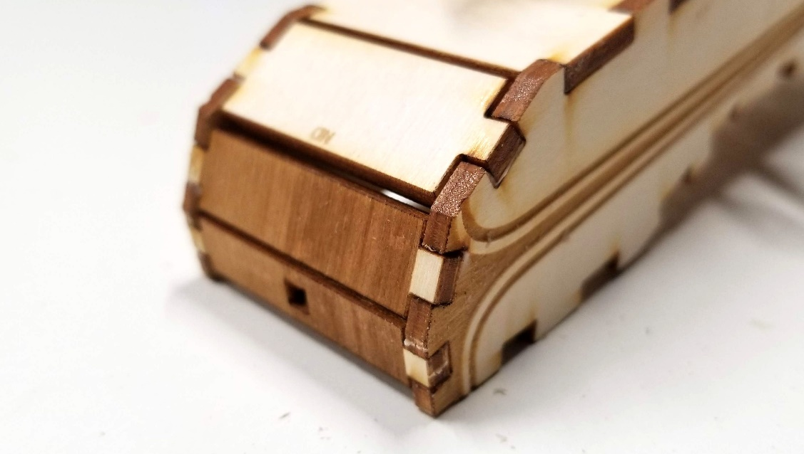

Step 6a: To assemble the wings, apply glue to the remaining tabs of B2, and the top rails of LG1 and LG2.
Place the wing, tabs first, at an angle to slot with B2, and rote down to connect with the slots of LG1 and LG2.
Tape the wings to LG1 and LG2 while the glue sets.
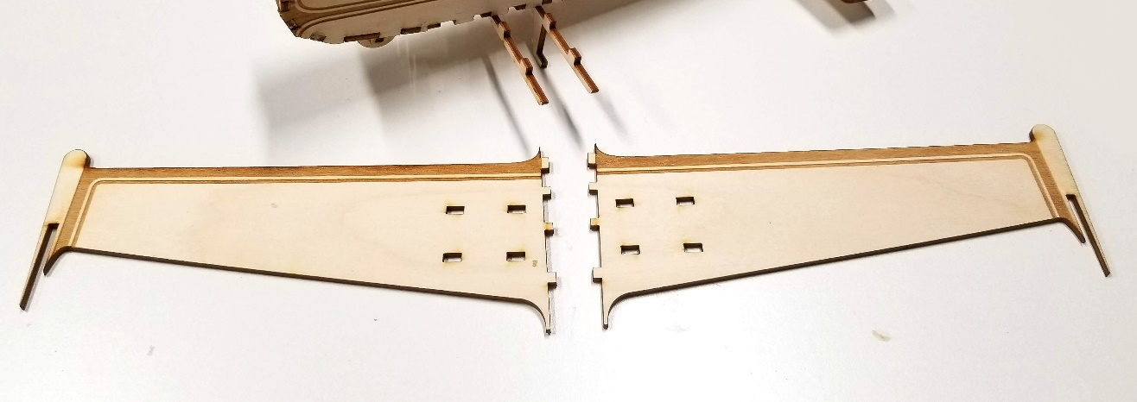
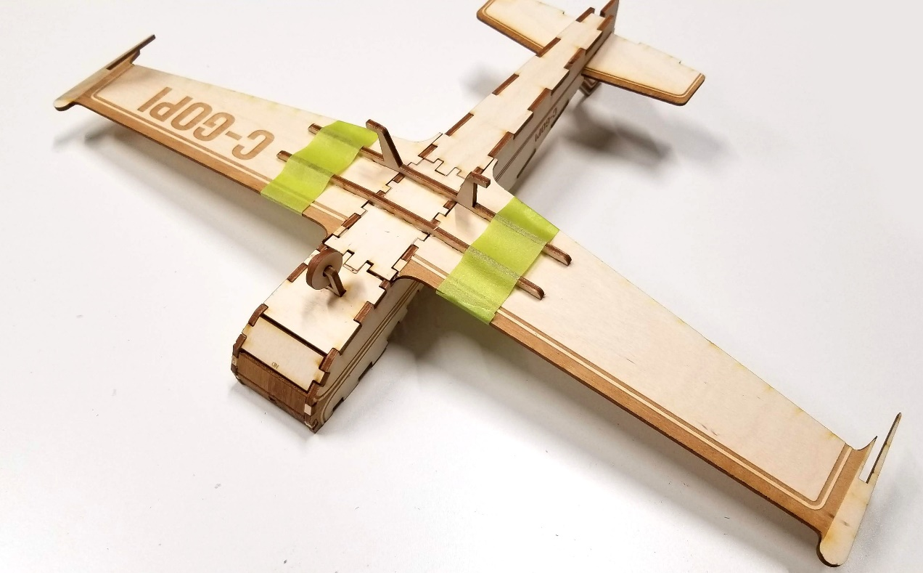
Step 6b: Apply glue to the slots of the winglets. And insert into the wing slots, with the etched side facing out.
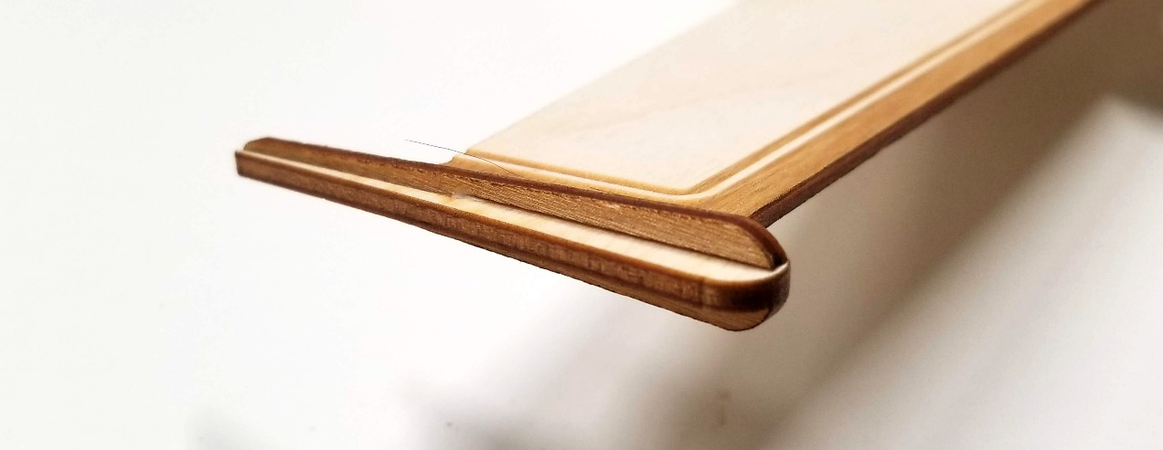

Step 7A: Gather the pieces for the canopy. Apply glue to the tabs of C1 and place into the C1 tabs of the fuselage. Stand the upright, while applying glue to the tabs or RB. Lean the C1 piece into each other until RB fits into place. This will be a little finicky until RC and RD are put in place.
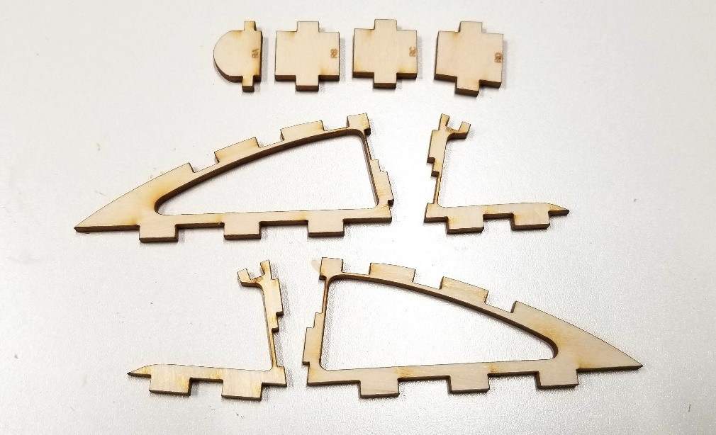
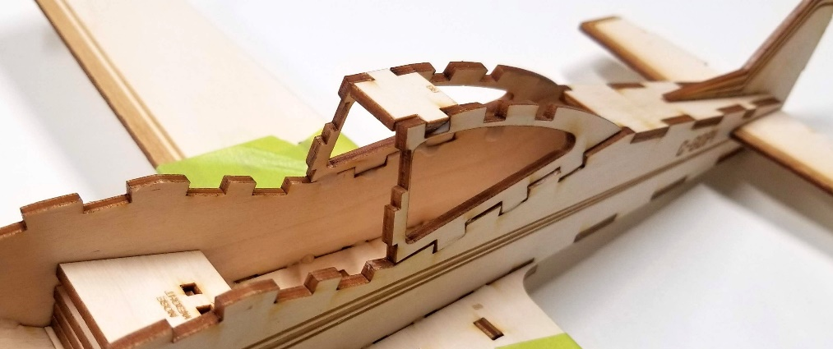
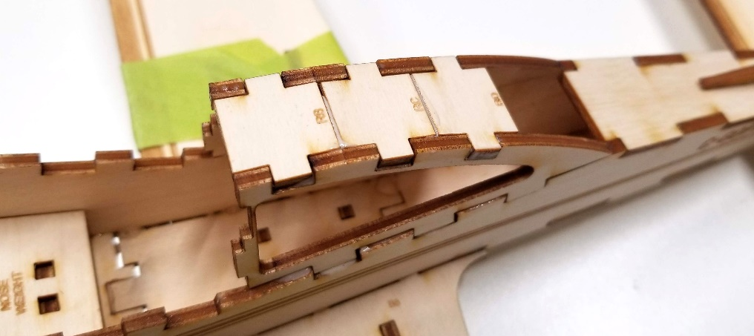

Step 7B: Follow the same steps of 7A for parts C2 and RA.
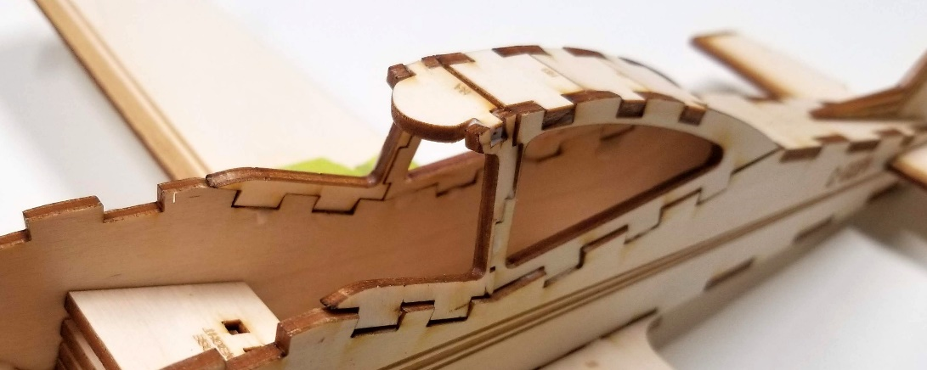
Step 8. Glue and place NA and NB in the appropriate slots. The curved end of NA represents tot front of the cockpit.
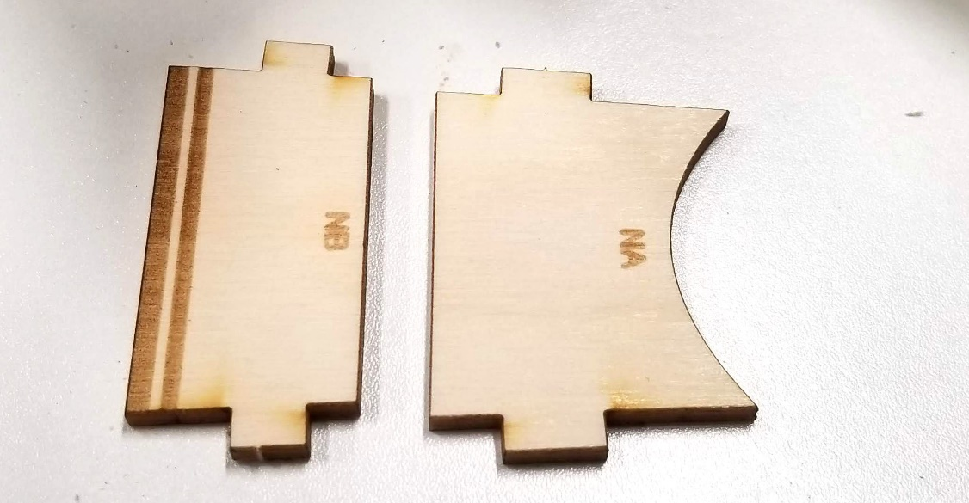
Step 9. Follow the same steps listed in Step 4b to secure the wheels to the landing gear.
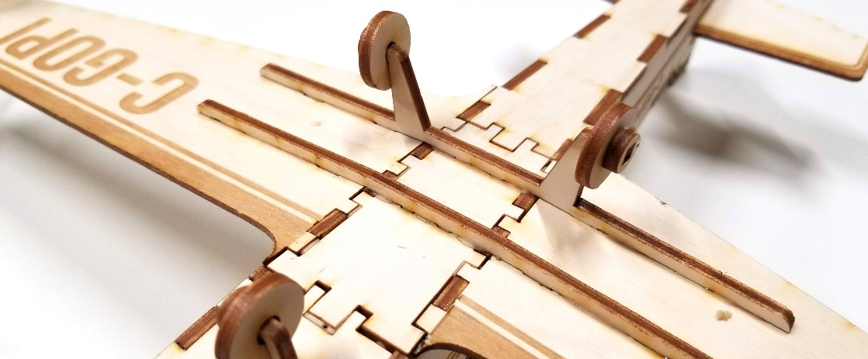

Step 10: To assemble the propeller, clue and slot together the nose cone, insert the tab through the propeller and into a glued slot on PM (unlabled). Make sure to leave enough space for the propeller to spin freely.
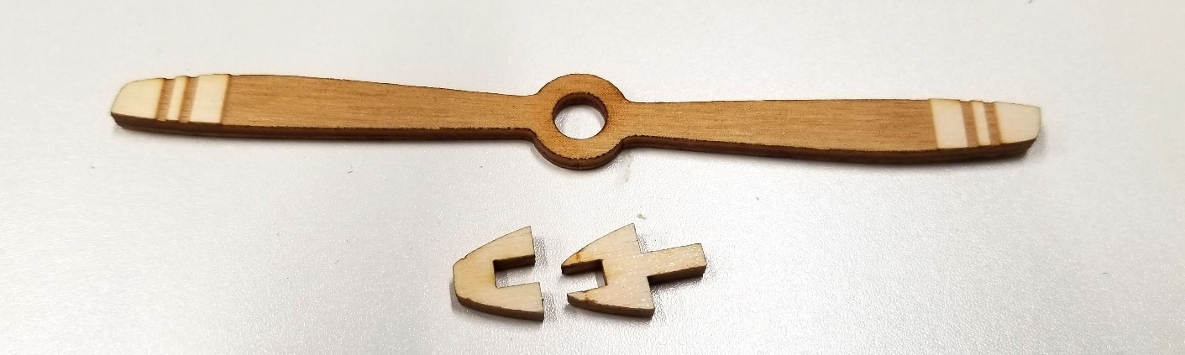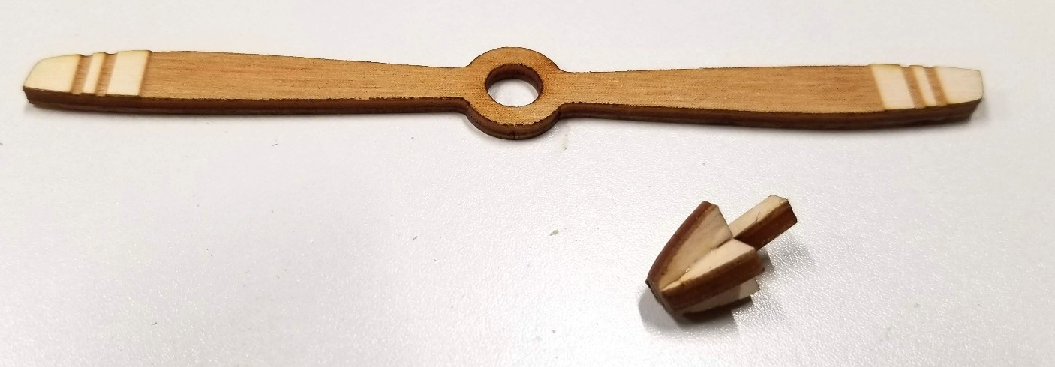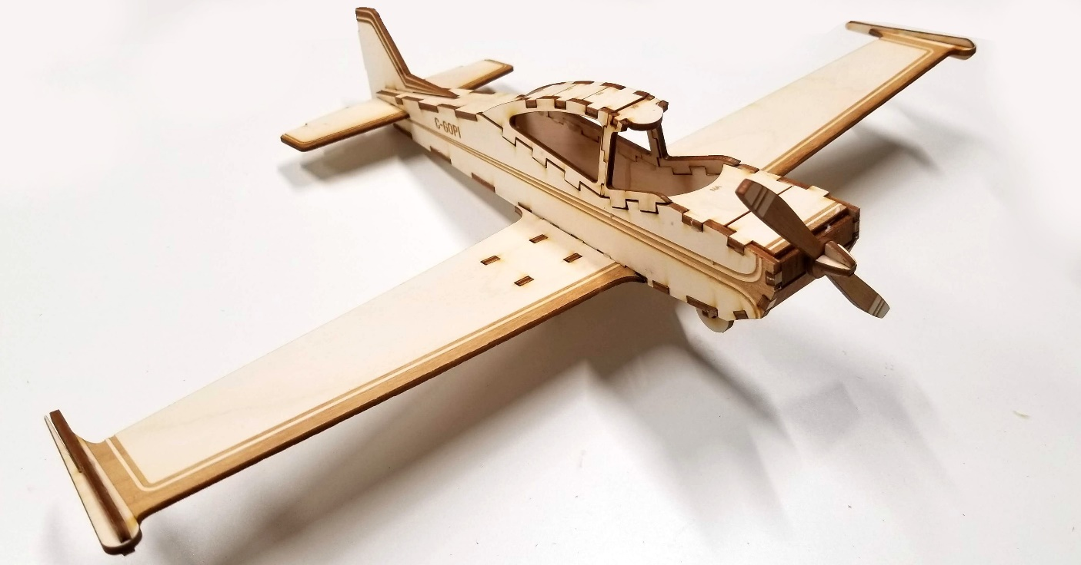

THAT’S IT!

